Assignment 10 (November 21 – November 26)

- 1. Which of the following functions on 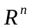 are concave or convex?
a) 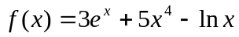, b) , c) 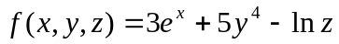, d) 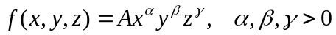.

- Graph each of the following sets, and indicate whether it is convex:
a) 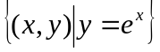, b) 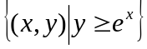, c) 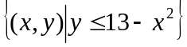,
d) 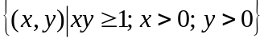.

Find critical points using the first-order conditions. To check whether a critical point is the optimal solution try the Weierstrass theorem where applicable.

3. 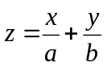 , if 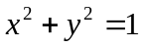

4. 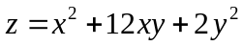, if 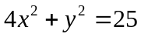

5. Maximize 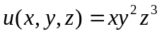 subject to 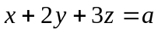, where 

